SINGLE INPUT, BALANCED OUTPUT DIFFERENTIAL AMPLIFIER
The circuit shown below is a dual-input balanced-output differential amplifier. Here in this circuit ,the input signals vin1, are applied to the bases B1 Q1 .The output vo is measured between the two collectors C1 and C2 which are at the same dc potential. Because of the equal dc potential at the two collectors with respect to ground, the output is referred as a balanced output.
Circuit Diagram:-
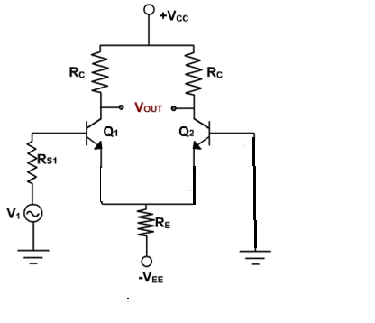

AC Analysis:-
To perform ac analysis to derive the expression for the voltage gains Ad and input resistance Ri of a differential amplifier:
1) Set the dc voltages +VCC and –VEE at 0
2) Substitute the small signal re equivalent models for the transistors

Figure below shows resulting ac equivalent circuit of the single input balanced output differential amplifier
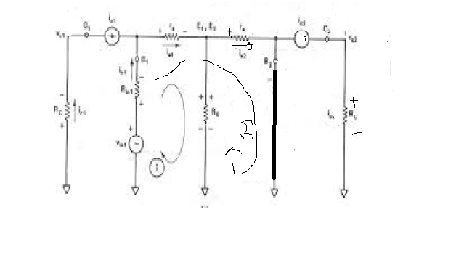
AC EQUIVALENT CIRCUIT FOR DUAL-INPUT BALANCED OUTPUT DIFFERETIAL AMPLIFIER
Writing Kirchhoff’s voltage equations for loops 1 and 2 gives us

v_{in1} – R_{in1}i_{b1} – r_{e}i_{e1} – R_{E} (i_{e1-}i_{e2}) = 0 (1)

v_{in1} – R_{in1}i_{b1} – r_{e}i_{e1} -r_{e}i_{e2} = 0 (2)

Substituting current relations i_{b}1 = i_{e1}/β _{ac} yields
v_{in1} – R_{in1} i_{e1}/β _{ac} – r_{e}i_{e1} – R_{E} (i_{e1}+i_{e2}) = 0 (3)

v_{in1} – R_{in1} i_{e1}/β _{ac} – r_{e}i_{e1} -r_{e}i_{e2} –= 0 (4)

Generally, R_{in1}/β _{ac} values are very small therefore we shall neglect them here for simplicity and rearrange these equations as follows:

(r_{e}+R_{E}) i_{e1} -R_{E}i_{e2} = v_{in1} (5)

r_{e}i_{e1} + r_{e}i_{e2} = v_{in1} (6)

Eqns (5) and (6) can be solved simultaneously for ie1 and ie2 by using Cramer’s rule:
i_{e1}= $\frac{\left|\begin{matrix}vin1 & -RE \\ vin1 & re\end{matrix}\right|}{\left|\begin{matrix}(re+RE) & -RE \\ re & re\end{matrix}\right|}$

i_{e2}= $\frac{\left|\left|\begin{matrix}(re+RE) & vin1 \\ re & vin1\end{matrix}\right|\right|}{\left|\begin{matrix}(re+RE) & -RE \\ re & re\end{matrix}\right|}$

i_{e1 =} [ v_{in1} (r_{e})+ v_{in1}R_{E}]/[ r_{e} (r_{e}+2R_{E})]

i_{e1 =} [ v_{in1} (r_{e}+ R_{E})]/[ r_{e} (r_{e}+2R_{E})] (7) and

i_{e2 =} [ v_{in1} (r_{e}+R_{E})- v_{in1}r_{e}]/[ r_{e} (r_{e}+2R_{E})]

i_{e2 =} [ v_{in1} R_{E}]/[ r_{e} (r_{e}+2R_{E})] (8)

The output voltage is
v_{o} = v_{c2} – v_{c1}
=R_{C}i_{c2} – (-R_{C}i_{c1}) (9)
= R_{C}i_{c1} + R_{C}i_{c2}
=R_{C} (i_{e1+} i_{e2}) since ic = ie
Substituting current relations ie1 and ie2 in eqn(9), we get
vo = = (RC/re) (vin1 )
we can write the voltage-gain equation of the single-input balanced-output differential amplifier as follows:
A_{d} = v_{o} /vin = R_{C}/r_{e} (10)
Differential Input Resistance:-
Differential input resistance is defined as the equivalent resistance that would be measured at either input terminal with the other terminal grounded.
Ri1 = |vin1/ib1|Vin2=0
=|vin/(ie1/βac)|Vin2=0
Substituting the value of ie1, we get
Ri1 = βacvin1/[{(re+RE)vin1/ r_{e} (r_{e}+2R_{E})}] (11)
=[βac(re²+2reRE)]/(re+RE)
=[βac re(re+2RE)]/(re+RE)
Generally,RE>>re, which implies that (re+2RE) = 2RE and (re+RE) = RE.
Therefore eqn(11) can be rewritten as
Ri1 = βacre(2RE)/RE = 2βacre (12)
Output Resistance:-
Output resistance is defined as the equivalent resistance that would be measured at either output terminal w.r.t ground.
Ro1 = Ro2 = R_{C} (13)
The current gain of the differential amplifier is undefined; therefore, the current-gain equation will not be derived for any of the four differential amplifier configurations.

